W228A/1204C, W228B/1204C



DUBLIN INSTITUTE OF TECHNOLOGY
_____________

DT228A/1 MSc in Computing
DT228B/1 MSc in Computing
______________

WINTER EXAMINATIONS 2016/2017
______________

Probability and Statistical Inference [Math9100]

Ms. deirdre Lawless
Dr. Deirdre Lillis
Mr. Conor sayles

[TBA Duration 2 hours]

Two Hours

Instructions to candidates

Answer question one and one other question.

All questions carry equal marks.

SOLUTIONS

Description of Statistical Research Inquiry used in All Questions
An organisation, which manufactures pharmaceuticals, has commissioned a research team to conduct a survey to investigate the level of satisfaction among its employees with the organisational culture. The organisation currently employees 20,000 people in eight different countries in three different continents. The majority of employees are employed in the manufacturing plants working on the production line. The majority of staff in the organisation are aged between 20 and 35.
A 5% cut-off level of statistical significance has been set for the project.
The research team decided to distribute the survey to employees in the headquarters of the organisation in each city in which the organisation has a presence worldwide. Finance, marketing, human resources and research and development processes are managed in these centres, employing 1,500 people; the majority are aged between 25 and 35. Five hundred and thirty six employees responded.
The research team conducting the survey also designed it. The survey consisted of ten Likert scale questions which asked employees to rate their agreement with the question topic and their perception of the importance of the question topic. The questions were designed by this research team based on research they conducted into the concept of employee satisfaction with organisational culture. This is the first time that the survey has been deployed. By aggregating the answers to these questions, the researcher has derived a total satisfaction score. In addition, the survey also collected respondents’ age and their length of service with the company (in years). The section of the survey relevant for this research is shown in Figure 1 on the next page. The variables of interest in the resulting dataset are shown in the table below.

Name | Label | Values | Type
age | Employee Age | 1 under 20; 2 21-30; 3 31-40; 4 41-50; 5 over 50 | Ordinal
Zservice | Standardised score of No. of years working in organisation |  | Scale
Ztotsatis | Standardised score of composite score representing an employee’s level of satisfaction |  | Scale

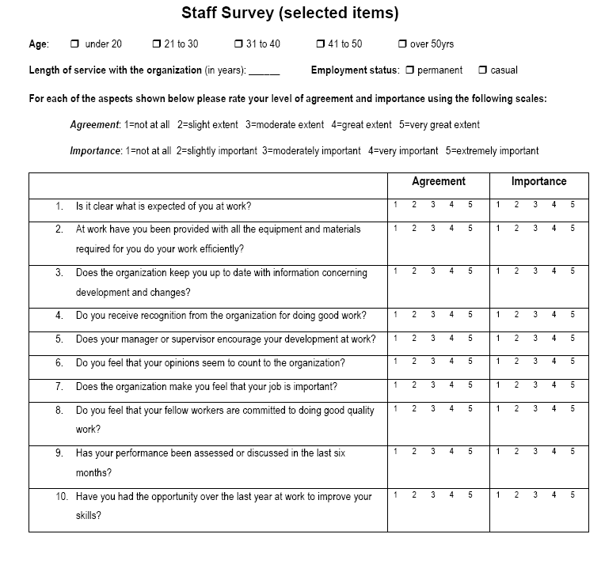
Figure 1: Section of Staff Survey

1. | (a) | The research team conducted an initial exploration of the data to identify its suitability for use in the proposed investigation. The team was particularly concerned with the following:  - Representativeness  - Outliers  - Central tendency and variability  - Clearly explain why each of the above can be a concern for a statistical inquiry.  (12 marks)
Marking Scheme/Sample Answer:
2 x 3 marks for correct definition of type I and type II errors
3 x 2 marks for discussion of each issue
Type I error: incorrect rejection of null hypothesis – false positive; Type II error: failure to reject null hypothesis – false negative
Representativeness: sample is drawn from population; size and randomness are issues; needs to reflect the population in terms of key characteristics and variables being investigated; source of bias and missing data.
Outliers: Cases with values very different to majority of data; a lot of statistical tests are sensitive to outliers; source of bias; can affect both assumptions of tests and results.
Central Tendency and Variability: most representative value and spread of data around this; important for description but also statistical tests depend on these two concepts; skewness and kurtosis – sources of bias.

1. | (a) | - Discuss what the research team can conclude about this dataset about each of these concerns for each of the variables of interest. Consider the description of the research inquiry provided and the descriptive statistics and graphs included in Appendix A.  (12 marks)
Marking Scheme/Sample Answer:
3 x 4 marks for discussion of each of the following
Length of service – positively skewed; should comment on level of skew; refer to histogram and tests; outliers exist – should discuss how many, how much of dataset falls within normal
Total Satisfaction – approx. normally distributed; should comment on histogram and tests; no significant outliers – should comment on how much of the dataset falls within normal
Age Category – representativeness; should consider missing values

1. | (a) | - Make recommendations which in your opinion would be most useful to address the issues of concern for this dataset.  (8 marks)
Marking Scheme/Sample Answer:
4 x 2 marks
Transform skewed variable (log transformation)
Use of Weighting variable to address representativeness or scaling/resample
Impute missing data; remove missing data
Dealing with outliers: Options delete, continue, repeat analysis twice

1. | (b) | The research team wishes to investigate the relationship/differences between:  - Age and Total satisfaction score  - Length of service and Total satisfaction score.  Based on your answers to part (a) and using the output of the tests in Appendix A for each pair of variables:  - Identify the test you feel is most appropriate to investigate the relationship/difference. Justify your answer.  (2 x 3 marks)
Marking Scheme/Sample Answer:
2 x 3 marks for each test (1 for selection, 2 for justification)
Age and totsatis: ANOVA (tot satisfaction is normally distributed, multiple categories for age)
Length of service and totsatis: Spearman (could select Pearson with bootstrap to address skew)
Marks will be given if alternate test is chosen with reasonable justification
- Interpret the output of the test you have chosen and explain what can be concluded about the relationship/differences between the variables in the context of the proposed research.
(2 x 6 marks)
Marking Scheme/Sample Answer:
2 x 6 marks: 2 marks identification of correct statistics; 2 marks for correct interpretation; 2 marks for comment on effect/difference
ANOVA: overall significance of omnibus test; F statistic; significant individual differences between groups; borderline significant at 0.05 level (0.052); difference between under-20, 21-30 and under-20 and over-50.
Spearman: overall significance; correlation co-efficient; covariance (r2); significant; small negative effect -.143; 2% of the covariance
Marks will be given if alternate test is chosen with reasonable justification/interpretation

2. | Having addressed the issues of concern identified in Q1, the research team has decided to further explore the relationship between the standardised total satisfaction score and the standardised length of service and age category. The team is interested in three different age groups under 30; 30 to 40 and over 40. To explore this age category has been recoded into two variables thirtytoforty (1 if between 31 and 40, 0 otherwise) and overforty (1 if over forty and 0 otherwise). A multiple linear regression model has been created using these variables and standardised length of service as the independent variables and standardised total satisfaction score as the dependent variable.
2. | (a) | Explain what linear regression could allow the research team to achieve in terms of their research. In your answer you should clearly explain the following:  - What regression will allow the researcher to do;  - What prediction means in this context;  - The type of variable used to include the age categories of interest in the model and why this type of variable is needed.  (12 marks)
Marking Scheme/Sample Answer:
3 marks explanation of what regression will allow researcher to do
3 marks explanation of what prediction is in this context
2 marks explanation of dummy variable; 2 marks explanation of need for them in this research; 2 marks correct identification of under 30 as reference category
Regression will allow researcher to explore how well a set of variables is able to predict an outcome variable; which variable in a set is the best predictor; whether a variable is still able to predict an outcome when controlling for a particular variables;
Prediction: looking at is the variance in the outcome variable and how much of the variance could be considered to be explained by the predictor variables. Should comment on variables involved
Dummy variable: interested in effect of characteristic, if include 1,2,3,4,5 etc. will act as multiplier, 0 and 1 can see effect and its absence; should address need to recode into multiple variables

2. | (b) | For the model created:  - Assess the fit and usefulness of the model created.  (12 marks)  - Explain how to interpret the model created for staff aged under 30, 30 to 40 and over 40 regardless of the significance of the model.  (16 marks)  In your answers you should state the regression equation, clearly explain any concepts or statistics to which you refer. Illustrate your answers by referring to the statistics included in Appendix B.
Marking Scheme/Sample Answer:
- 3 x 4 marks explanation and assessment of the coefficients, R2 and F statistic (2 marks explanation 2 marks assessment);
- 4 marks correct statement of equation; 3 x 4 marks correct interpretation of equation for under 30, 30 to 40 and over 40.
F statistic: Whether the model as a whole predicts the dependent variable; Its statistical significance is the significance of the model; Model is not significant
Coefficients: Measure the strength and direction of relationships between independent variables and the dependent variance – need to consider the significance of these R2: the proportion of variance in the outcome (dependent) variable which can be explained by the predictor (independent) variables. An R2 of 1 means the independent variable explains 100% of the variance in the dependent variable. Conversely 0 means it explains none. Model explains 2% of variance
Equation: ztotsatis=.024 + .066*30 to 40 + .102 * over40 -.143 * zservice
Should plug values in for under 30, 30 to 40, over 40
2. | (c) | If you were asked to choose between exploratory factor analysis and principal component analysis to create a composite score of total satisfaction from their answers to q1a to q10a, which technique would you recommend and why?  (10 marks)
Marking Scheme/Sample Answer:
3 marks objectives of EFA and PCA; 5 marks differences/different uses 2 marks choice
Objectives: Reduce the number of variables; Development of parsimonious (simple) analysis and interpretation;
Differences/Use EFA and PCA: EFA Determine the nature of and the number of latent variables that account for observed variation and covariation among set of observed indicators; Used to develop theoretical constructs;; PCA Reduce multiple observed variables into fewer components that summarize their variance;
Should choose EFA : Used to prove/disprove proposed theories;

3. |  | Rather than use an aggregate score from the relevant questions as currently exists in the dataset, the research team want to use Exploratory Factor Analysis to derive the composite score for total satisfaction from respondents’ agreement with questions 1 to 5.  Explain what this approach will allow the research team to achieve and discuss the suitability of the dataset for use with this approach.  In your answers you should clearly explain any concepts or statistics to which you refer. Illustrate your answers by referring to the statistics included in Appendix C.  (20 marks)
Marking Scheme/Sample Answer:
3 marks objectives; 2 marks use for the research team; 3 marks Sample size and sample to variable ratio (1 for explanation, 2 for interpretation); 5 marks Factorability of the correlation matrix (2 for explanation, 3 for interpretation); 4 marks KMO/Bartlett's (2 for explanation, 2 for interpretation); 3 marks Reliability (1 for explanation, 2 for interpretation)
Objectives: Reduce the number of variables; Evaluates the construct validity of a scale, test, or instrument; Development of parsimonious (simple) analysis and interpretation; Addresses multicollinearity (two or more variables that are correlated)
EFA Determines the nature of and the number of latent variables that account for observed variation and covariation among set of observed indicators; Used to develop theoretical constructs; Used to prove/disprove proposed theories; only shared variance is used;
Sample size, sample to variable: generally at least 300 cases needed; N:p ratio where N = no of cases, p=no of variables rule of thumb 10:1. Possible issue.
Factorability of the matrix: looking at relationships between individual variables; correlation coefficients >0.30 indicates useful for EFA. Here have correlations between q1a and q2a; q2a and q3a;q3a and q4a; q3a and q5a; q4a and q5a
KMO proportion of variance in variables that might be caused by an underlying factor. High values close to 1 suggest that FA useful, anything less than 0.5 FA won’t be useful. Bartlett tests that variables are correlated. Looking for a statistically significant p value which suggests that they are related and a FA would be useful. No issues for this data.
Reliability accuracy and precision of a measurement procedure; Cronbach’s alpha – index of reliability associated with the variation accounted for by the true score of the "underlying construct"; Acceptable level depend on the purpose of the instrument. Acceptable 0.60. For this data it is 0.716. No significant improvement by deleting items.

3. | (b) | Discuss the outcomes of the application of exploratory factor analysis and assess its effectiveness for the purposes of the research team.  (18 marks)  In your answers you should clearly explain any concepts or statistics to which you refer. Illustrate your answers by referring to the statistics included in Appendix C.
Marking Scheme/Sample Answer:
4 marks correct identification of factors; 4 marks communalities (2 for meaning, 2 for application); 4 marks variance (2 for meaning, 2 for application); 6 marks loadings (2 for meaning, 2 for pre-rotation and 2 for post-rotation);
Extraction: Need to decide how many factors to retain. Criteria for extraction: Kaiser’s criteria (eigenvalue > 1 rule), the Scree test, the cumulative percent of variance extracted. 2 factors
Communalities: proportion of the common variance within a variable; looking at extraction column
Should look at factor loadings before rotation and after to see differences if any
Rotation: Unrotated results from a factor analysis are not easy to interpret, although the plot helps. Rotation helps clarify and simplify the results of a factor analysis. Conceptually, the axes are being rotated so that the clusters of items fall as closely as possible to them. Making the factor loading pattern much clearer as one of the two pairs of coordinates for each item tends to be close to 0.00
Variance: Looking at total variance explained for factors with eigenvalues > 1; factor 1 explains 38.29 % of total variance; factor 2 10.8 After rotation factor 1 14.3, 2 11.1, 3 10.9; Rotation equalises the importance of the factors.
3. | (c) | Suppose the first factor extracted during exploratory factor analysis has been saved to the dataset as efatotsatis (EFA generated total satisfaction score) and that the research team wish to build a regression model using standardised length of service and age category as predictors of this new variable.  Briefly discuss the main assumptions that must be met for the independent and dependent variables when undertaking a linear regression.  Illustrate your answer by reference to the statistics provided for the variables of interest in Appendix A, Appendix B and Appendix C.  (12 marks)
Marking Scheme/Sample Answer:
4 x 3 marks (2 marks for explanation; 1 mark for illustration)
Variable Type: Outcome must be continuous; Predictors can be continuous or dichotomous.
Non-Zero Variance: Predictors must not have zero variance.
Linearity: The relationship we model is, in reality, linear. Should refer to tests in Q1.
Independence: All values of the outcome should come from a different case.

Descriptives: Length of Service and Total Satisfaction
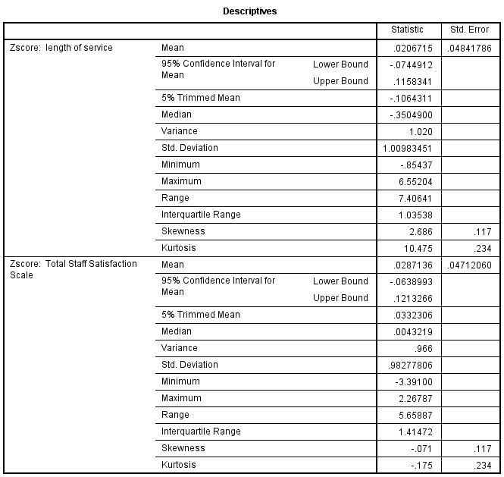 | 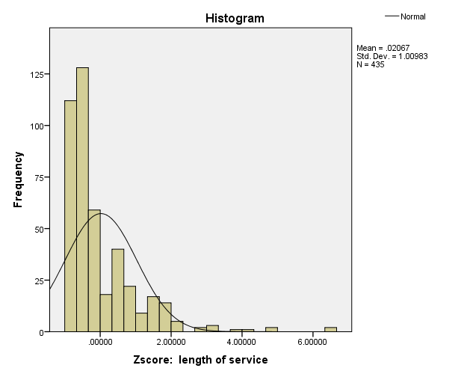  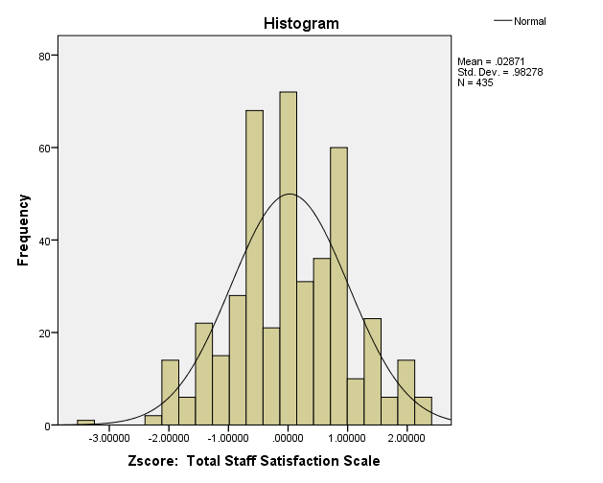

Descriptives: Length of Service and Total Satisfaction
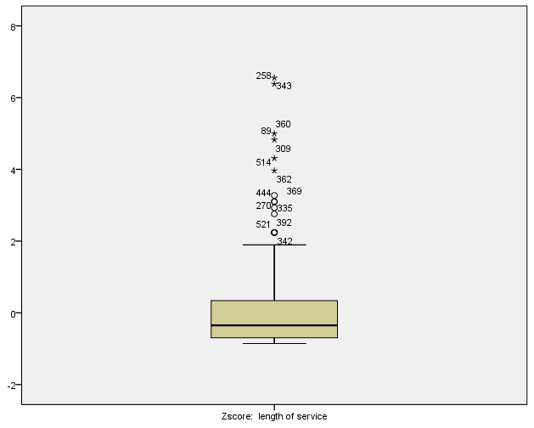 | 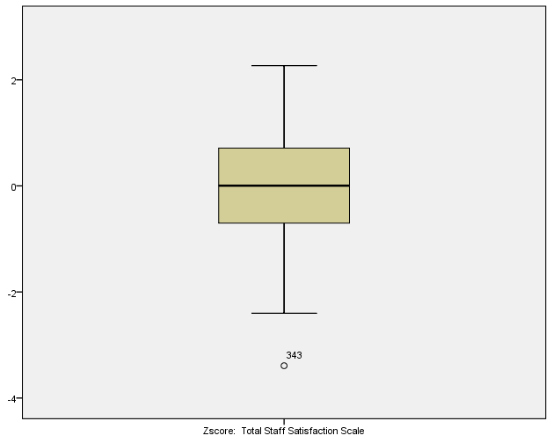
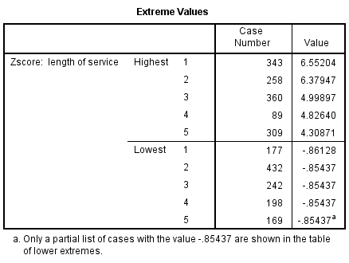 | 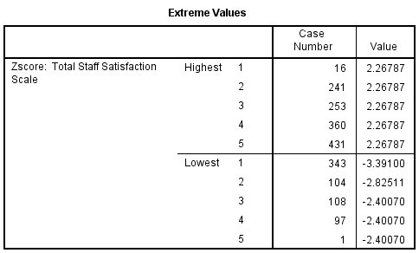

Descriptives: Age Category
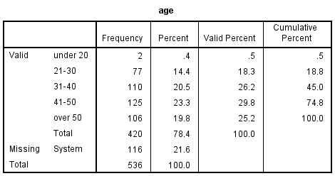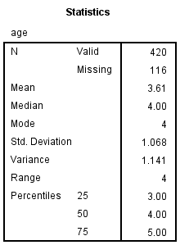 | 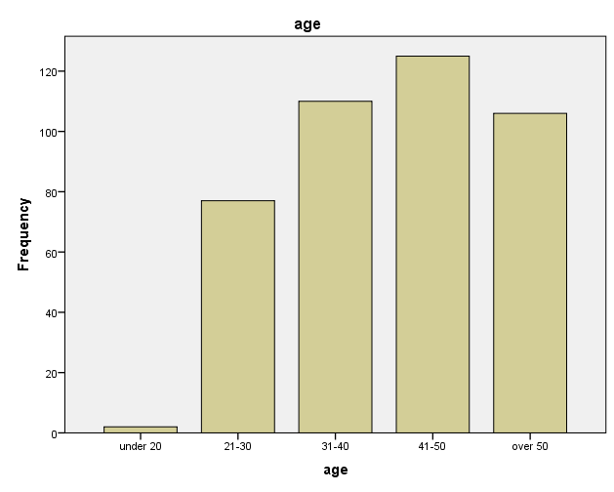

Tests: Age and Total Satisfaction | 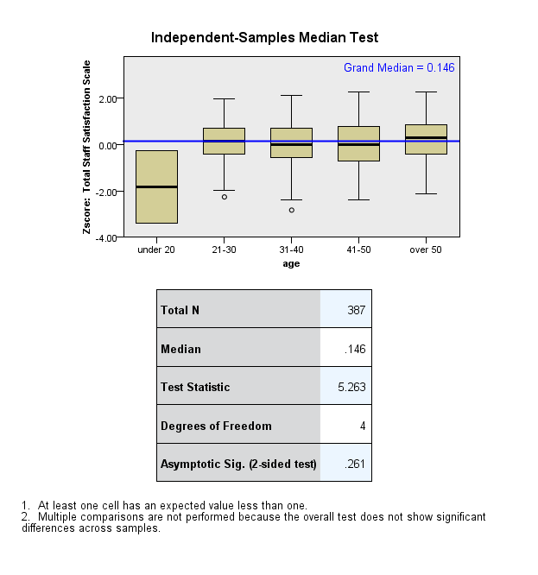
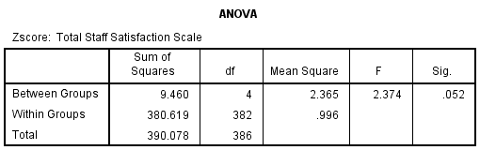
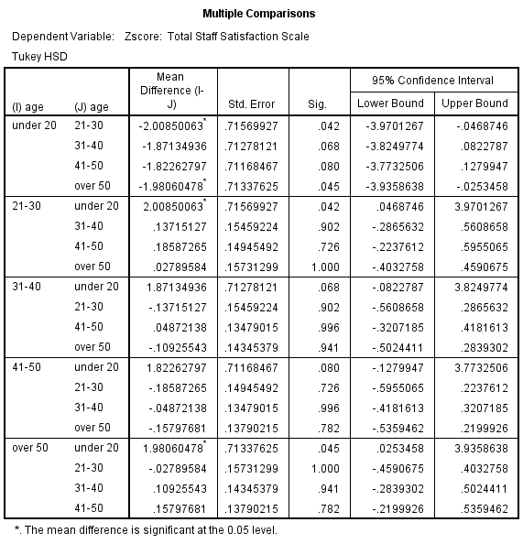

Test: Length of Service and Total Satistfaction
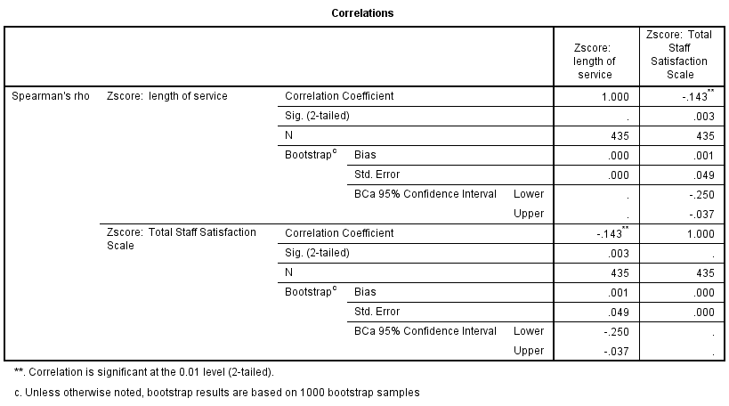
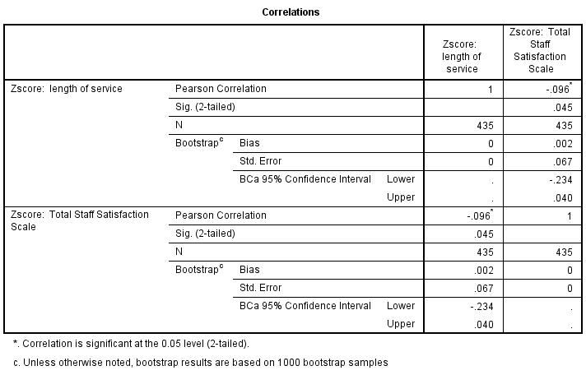

Independent t-tests  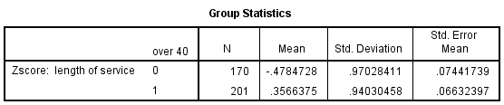 |  | 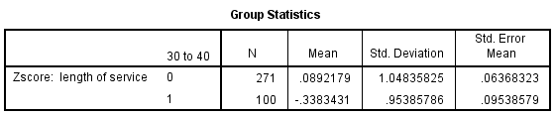
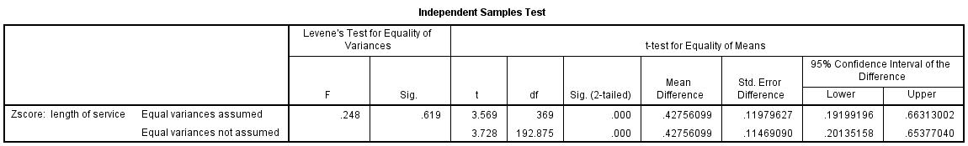
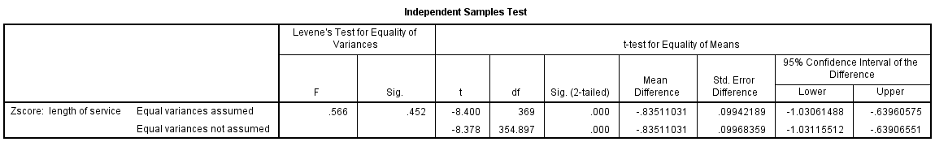
Multiple Linear Regression
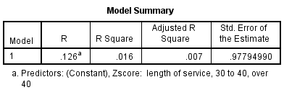
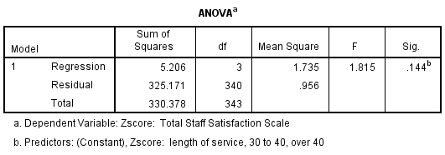 | 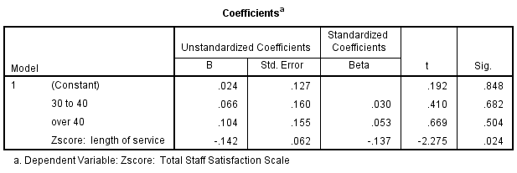

Exploratory Factor Analysis
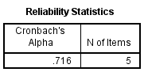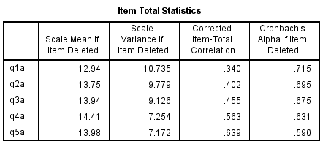 | 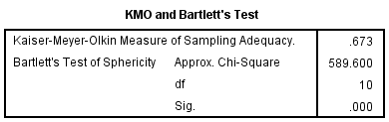
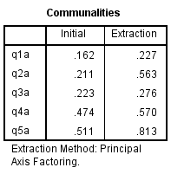 | 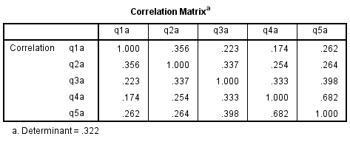
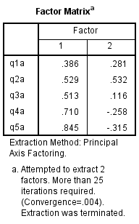 | 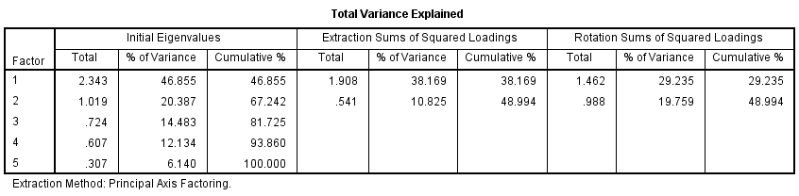
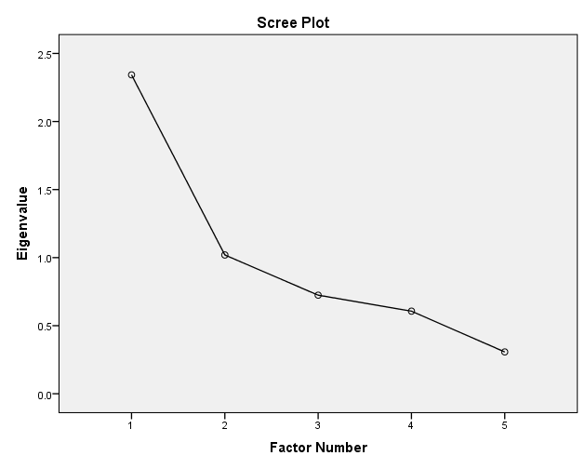 | 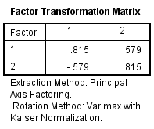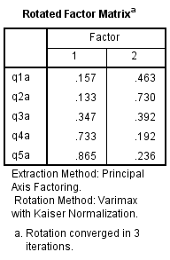
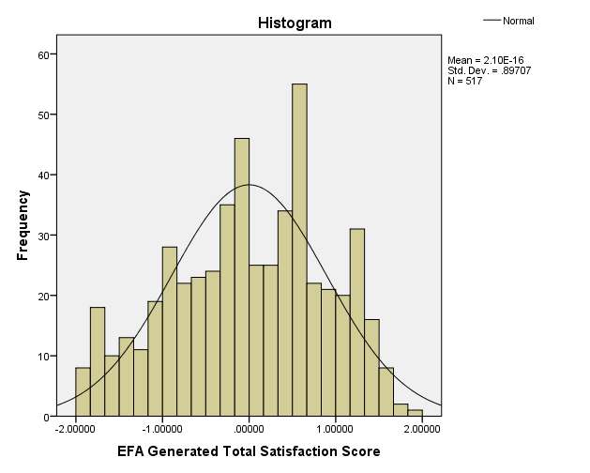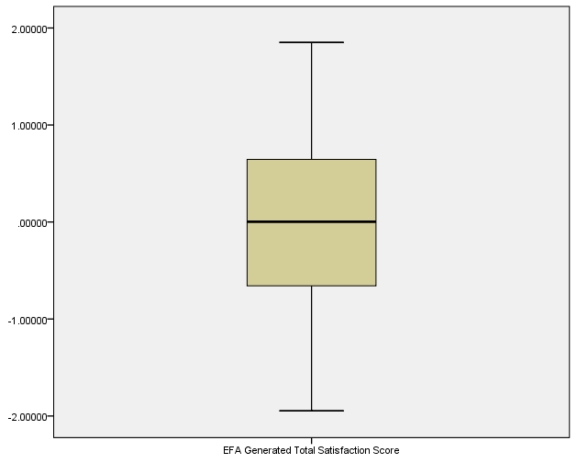 | 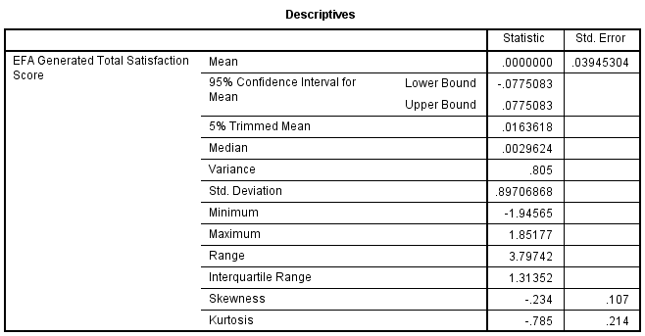

The dataset used in this exam paper is adapted from one included in J. Pallant, SPSS Survival Manual, 6th Edition, Allen and Unwin

